Rédiger une intro un peu plus générale, parler des travaux du groupe de Nassia sur les souris.

The relationship between G-actin and MRTF-A is well documented. MRTF-A binds 3 to 5 actin monomers through 3 RPEL repeats (posern 2004, mouilleron 2008, hirano 2011). The nuclear localization signal (NLS) is embedded inside the 3 RPEL (rajajyla 2010), thus making its availability dependent on G-actin binding. When actin is bound to MRTF-A, the NLS is hidden and MRTF-A is cytoplasmic (posern 2002 & 2004, miralles 2003), whereas when actin is scarce, the NLS is available and MRTF-A can accumulate in the nucleus. On the contrary, a G-actin scarcity in the nucleus has been shown to hinder MRTF-A exiting from the nucleus (baarlink 2012). The localization of MRTF-A in the cell is thus closely linked to the G-actin pool available to bind it and maintain it in the cytoplasm. Actin polymerizing drugs, such as jasplakinolide (miralles 2003, vartiainen 2007), highly polymerizable actin mutants (posern 2004) or actin sequestering drugs such as cytochalasin D deplete the G-actin pool and induce the transfer of MRTF-A to the nucleus. On the contrary?, non polymerizable actin mutants (posern 2002, miralles 2003), actin over-expression (miralles 2003, vartiainen 2007) or latrunculin B, which is compatible with MRTF-A actin binding, participates in sequestering actin in the cytoplasm. While the role of biochemicals in this pathway has been widely studied, the influence of mechanical cues on the MRTF-A/SRF pathway through actin organization has been less investigated.

Mechanical cues are well known to induce reorganization of the actin cytoskeleton in a great variety of cell types and conditions (***à voir dans Shao 2015***). Both the mechanical properties of the substrate, and the forces (mechanical stresses?) and strains the cells are subjected to, can promote actin polymerization (Discher Science 2005, Chambliss 2013, ***Greiner 2013***, Shao 2015). At the muscle level, MRTF-A and SRF have been shown to control the increase in muscle mass following a mechanical hyper-stimulation and the atrophy following an immobilization, linking through this pathway mechanical stimuli and genetic response (Guerci 2012, Collard 2014). Our purpose is thus to bring together those different pieces, from the mechanically induced cytoskeletal reorganization to the MRTF-A/SRF transcription pathway. The main questions we want to address are: What kind of mechanical cues are able to reorganize the actin cytoskeleton enough to induce changes in MRTF-A intracellular localization? What are the timescales involved?

To answer these questions, we used two different custom-built devices to apply mechanical stimuli at the cell level: we applied either a local force through fibronectin-coated micron-sized beads controlled by magnetic tweezers, or a global deformation through stretchable PDMS substrates. Both the localization of MRTF-A and actin polymerization were monitored through time thanks to fluorescence labellings.

**Results**

**The subcellular localization of MRTF-A is correlated to its expression level and to the globular actin level**

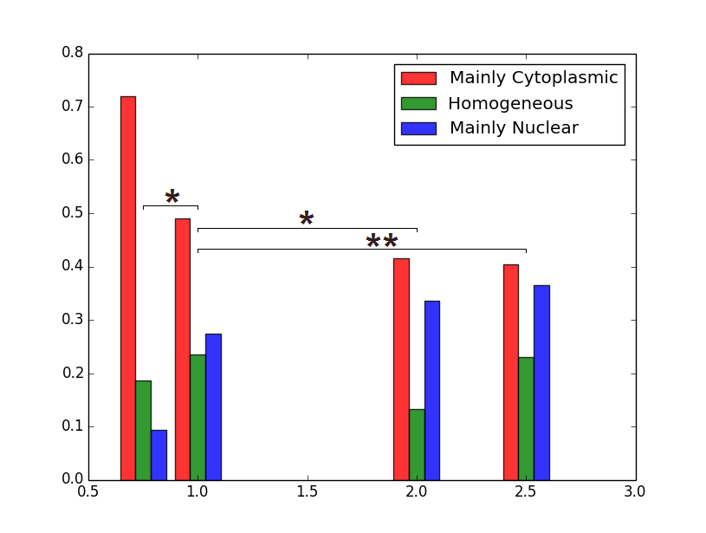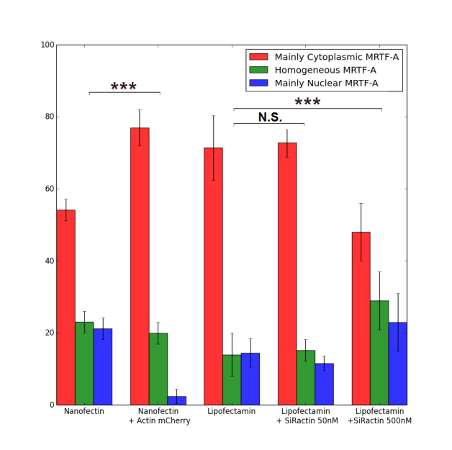

Figure 1 Localization of MRTF-A GFP (a) as a function of the mass of MRTF-A GFP plasmid DNA used for the transfection with nanofectine. More DNA leads to nuclear accumulation of MRTF-A due to its overexpression compared to the G-actin pool (0.75µg : 75 cells, 1.0µg 260 cells, 2.0µg : 113 cells, 2.5µg 126 cells); (b) as a function of tranfection reagent, actin overexpression and F-actin stabilizing fluorescent marker SiRactin

As-tu des résultats fiables sur la localisation de l’endogène ?

C2C12 myoblasts were transfected with a plasmid coding for MRTF-A-GFP. The localization of MRTF-A GFP in the cell was then observed by fluorescence microscopy, and the cells were classified between three categories according to the main localization of MRTF-A GFP signal: mainly cytoplasmic (“C”), mainly nuclear (“N”) or homogeneously distributed (“H”). Different levels of plasmid concentration were tested for transfection with Nanofectin, ranging from 0.75µg to 2.5µg of DNA for 110 000 cells. At the lowest level of plasmid, MRTF-A GFP is mainly cytoplasmic in more than 70% of the cells, whereas at the highest levels, the percentage of “C” cells drops to less than 40. The more plasmid is supplied, the more nuclear MRTF-A is. This is consistent with the mechanisms known for the regulation of MRTF-A intracellular organization through G-actin binding: when MRTF-A is overexpressed due to many plasmid copies, there are not enough G-actin monomers to bind it and maintain it in the cytoplasm. The excess in MRTF-A is thus free to accumulate in the nucleus. For the following experiments, we always used the 1µg of MRTF-A GFP DNA dose, as a compromise between sufficient transfection efficiency and low overexpression.

For better transfection efficiency, we also tried Lipofectamin 3000 with the same low MRTF-A GFP dosage (1µg DNA for 110 000 cells). In the same experimental conditions, the localization of MRTF-A GFP was significantly more cytoplasmic ~~(p=3.10~~~~-4~~~~)~~ while the transfection efficiency increased, from about 20% of cells expressing MRTF-A-GFP with Nanofectin to about 40% with Lipofectamin 3000 (??) . Consistently with the previous dose-response experiment, the difference between the two transfection methods can be understood as Lipofectamin 3000 delivering the same amount of plasmid to more cells, each of them experiencing less MRTF-A overexpression, leading to more cytoplasmic (plutôt: less nuclear?) localization of the protein.

The same effect could be obtained by playing with the availability of MRTF-A partner G-actin. Co-transfection of mCherry-actin leads to overexpression of actin and to a larger G-actin pool, contributing to the sequestration of MRTF-A in the cytoplasm as can be seen in the marked increase of cytoplasmic localization (figure 2). The opposite effect can be obtained by using large concentration of SiRactin, a fluorescent F-actin marker derived from F-actin stabilizing drug jasplakinolide: the G-actin pool is reduced by the F-actin stabilization, and MRTF-A is accumulated in the nucleus, with only one cell out of two displaying a successful retaining (??) of MRTF-A in the cytoplasm. A 10-fold lower level of SiRactin caused no measurable change in the initial localization of MRTF-A and was subsequently used for F-actin labelling.

**Local force application induces actin polymerization and accumulation of MRTF-A in the nucleus**

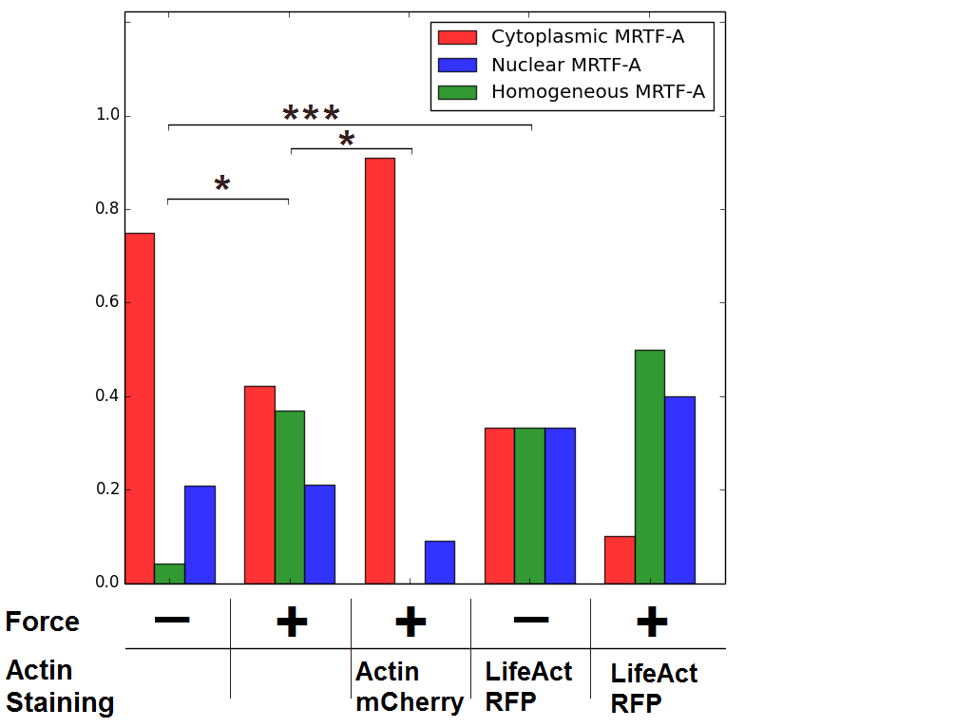

Figure 3 Final state of MRTF-A localization in cells subjected to 1nN force through a fibronectin-coated adherent microbead. The force was applied for 125 seconds repeated 6 times. Number of cells : 29 for the control, 23 with force, 11 with mCherry actin and force, 10 for control with LifeAct and 6 for force with LifeAct. P values were calculated with Fisher’s exact test (*: p<0.05, **:p<0.01, ***:p<0.0001). 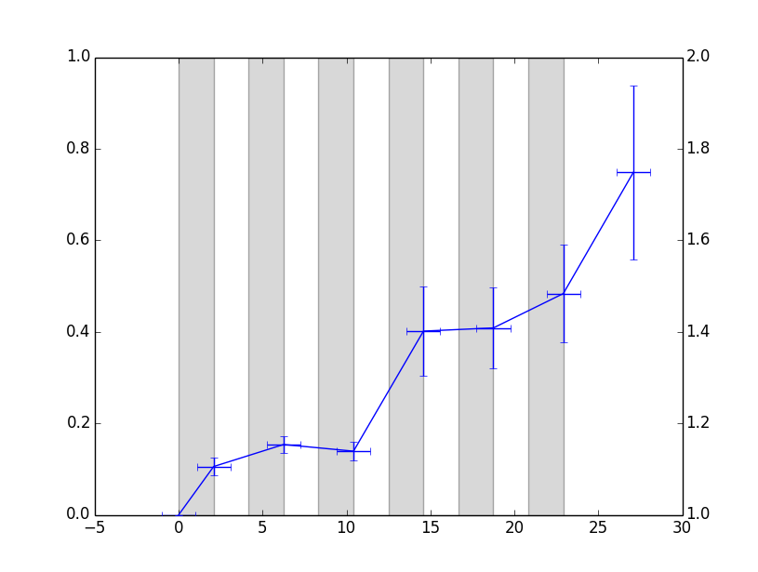

Figure 4 Increase of LifeAct fluorescent intensity around beads subjected to repeated force as compared to the whole cell (6 cells). Mettre 1 point toutes les 4 min et mettre un 2e axe des ordonnées avec la force.

The first experiments were performed using magnetic tweezers which apply a 1nN force on an adherent superparamagnetic microbeads (4.5µm diameter) coated with fibronectin. The force was applied for 2 minutes, and then released for 2 minutes and this cycle was repeated 6 times. The localization of MRTF-A GFP was observed at the end of each force application. The final localization of MRTF-A in different experimental conditions is shown on figure 3. Initially the localization of MRTF-A is not significantly different in any of the condition, though the mCherry actin expressing cells already display a more cytoplasmic localization (not shown). At the end of 6 cycles of force application, MRTF-A is significantly more nuclear in mechanically stimulated cells as compared to control cells, as expected if the 1nN applied force promotes F-actin polymerization. This effect can be blocked by overexpressing actin through mCherry actin co-transfection, most probably because the larger G-actin pool cannot be efficiently depleted by force-induced F-actin polymerization. In order to visualize increased actin polymerization in response to force, fluorescent LifeAct was co-transfected with MRTF-A GFP. Unfortunately, LifeAct had a strong F-actin stabilizing effect in our cells, causing MRTF-A to accumulate in the nucleus even in the absence of mechanical stimulation (see Fig. 3). However, a marked increase of LifeAct fluorescence intensity was measured around beads subjected to repeated forces, with actin forming a ring at the attachment zone, similarly to what was previously observed on the same cell type expressing GFP-actin with RGD-coated microbeads actuated with optical tweezers (Icard 2008).

Trouver une transition entre les pinces et l’étirement.

**Global cell stretching changes actin polymerization state and MRTF-A sub-cellular localization**

Cells were seeded on stretchable PDMS disks coated with fibronectin, and subjected to 0 to 30% static strain starting at time t=0. They could then either be fixed for further staining and observation after some time of stretching, or observed live to follow the changes in localization of MRTF-A through time after the start of stretching. Two different strain rates were explored, a moderate strain of 10% increase in area and a higher 30% strain.

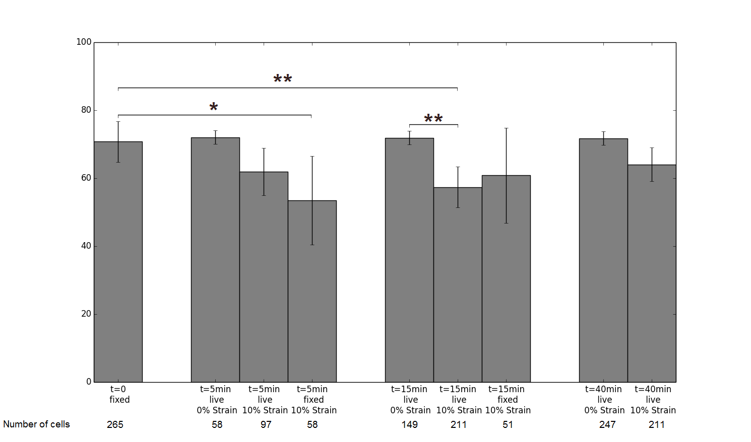

Figure 5 Proportion of cells where MRTF-A is mainly cytoplasmic at different times after the start of stretching. Ajouter les p-values.

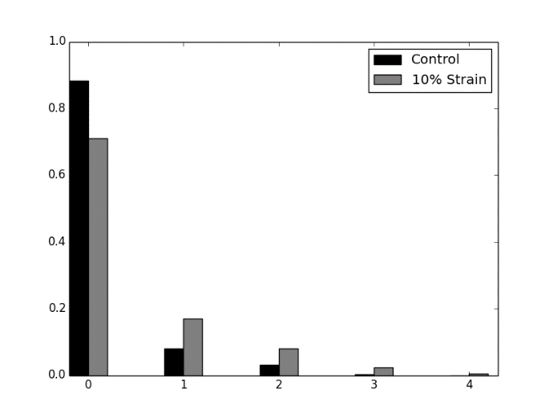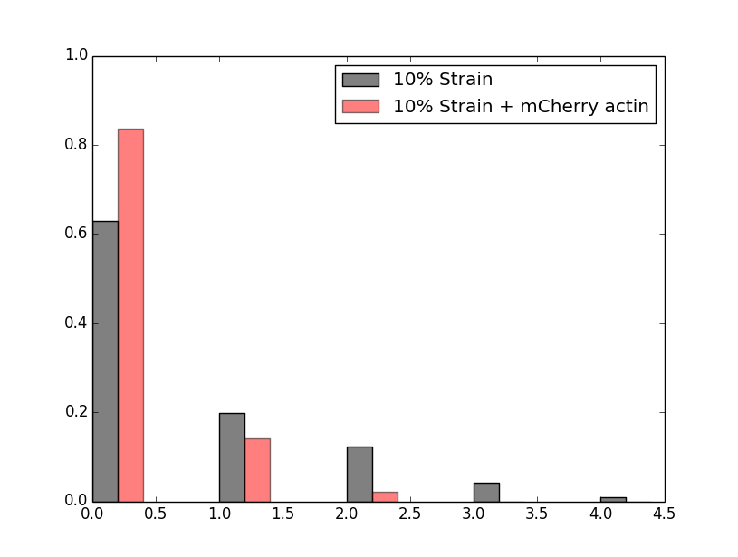

Figure 6 Proportion of cells experiencing 0 to 4 changes in MRTF-A main localization during the 120 minutes of observation (a) 10% strain (211 cells) vs control (249 cells); the two populations significantly differ p=2.10-5 (G-test); (b) 10% stretching, with or without co-transfection with mCherry actin. The two populations significantly differ p=2.10-4 (G-test).

The proportion of cells displaying a cytoplasmic localization of MRTF-A after 5, 15 and 40 minutes of stretching are shown on figure 5. A decrease in cytoplasmic localization under stretch is observed. For experiments in which cells were fixed, this decrease is significant as soon as 5 minutes after starting the stretch, whereas it is not for live experiments, presumably because the number of cells in the statistic at that time is too low. However, at 15 minutes, with more cells, live experiments also show a marked decrease in cytoplasmic localization of MRTF-A. This is consistent with a mechanically-induced polymerization of actin which exhausts (? depletes?) the G-actin pool, causing MRTF-A to relocate to the nucleus. The details of actin polymerization in response to strain will be addressed later in the text. During live experiments, the rate of changes in localization of MRTF-A can also be measured, for example by counting the number of times the state of a given cell changes (between “C”, “H” and “N”) for the 120 minutes of observation. The results are displayed in figure 6: the number of cells exhibiting a relocation of MRTF-A is significantly higher when stretching.

We had two different ways to try and observe a more radical effect of the mechanics on MRTF-A localization: adding more MRTF-A so that the cells have a smaller G-actin pool, or applying a greater strain.

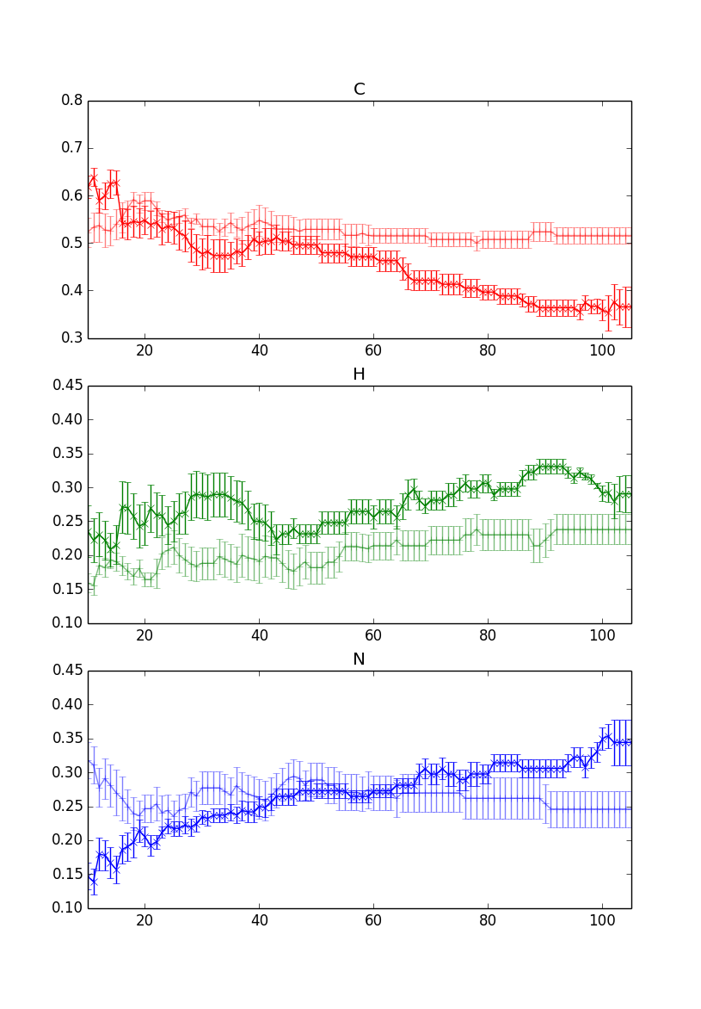

Figure 8 Proportion of cells with cytoplasmic MRTF-A through time after applying 10% strain at t=0 versus control.

Repeating the same 10% Strain experiment on Nanofectin-transfected cells with a higher MRTF-A pool pool, we observed a nuclear accumulation at longer timescales, up to a minimum in cytoplasmic localization of roughly one cell out of three around 90 minutes after stretching. The nuclear accumulation seems more durable and more important than for lipofectamin-transfected cells, consistently with higher MRTF-A to G-actin ratio. Dynamically, there is no significant difference in the number of relocation per cell between nanofectin and lipofectamin transfected cells. However, cells with mainly cytoplasmic MRTF-A accumulates MRTF-A in the nucleus more often when nanofectin is used, as expected when the G-actin pool is easier to deplete, and cells with mainly nuclear MRTF-A expel it less often, as expected when MRTF-A is overexpressed. Altogether, a mechanical stimulation of 10% strain can induce nuclear accumulation of MRTF-A in myoblasts, and the scarcer the G-actin, the easier and more durable this effect can be. On the contrary, when mCherry actin is co-transfected with MRTF-A, the nuclear accumulation and its dynamics is completely abolished, as the G-actin pool is much larger.

Stretching at higher strain rates was expected to induce more polymerization of actin and a stronger nuclear accumulation of MRTF-A. However, though the initial response at t=5 minutes seems to be close to the one previously observed with 10% strain, the following events are very different. The nuclear accumulation at t=5minutes does not last, and is followed by a nuclear expulsion, so that at t=40 minutes the localization of MRTF-A is identical to the one of non-stretched cells. At longer timescales (t=80minutes), the cytoplasmic localization of MRTF-A is higher in cells subjected to 30% strain. The number of relocating cells is not significantly different than for 10% strain, but the relocation events are more often MRTF-A accumulating in the cytoplasm instead of in the nucleus. The response at higher strain is thus widely different from the one at moderate strain.